Open Call for Academic Leadership Roles in Environmental Science, Applied Mathematics, and Public Communication of Science, supporting the UK Geodisposal programme
Post Reference: RWMRSO/DL001/ENV; RWMRSO/DL002/MATH; RWMRSO/DL003/PCOS
No of roles: 3
Duration: Up to 6 days pa
Remuneration: Honorarium
Closing Date: 11/10/2020
Post Category: Discipline Lead (academic)
Business Unit: RWM RSO
Location: UK-wide
Background. The Universities of Manchester and Sheffield are collaborating to host the Radioactive Waste Management Ltd (RWM) Research Support Office (RSO). The RSO is led by Katherine Morris (Manchester), Neil Hyatt (Sheffield) and Sam Shaw (Manchester) with Lucy Bailey as the RWM lead and will act as a hub, with the mission to work with leading universities to deliver and co-ordinate research aligned to RWM’s needs.
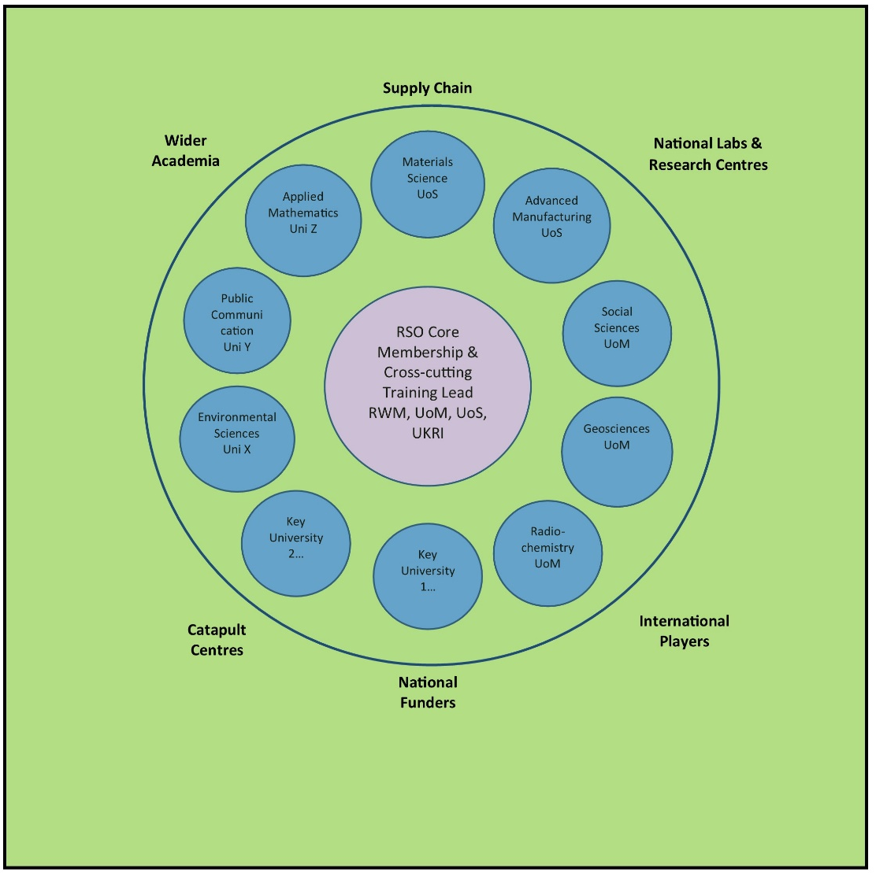
The RSO is currently being established and, as part of this process, we need to build a team of domain experts (‘Discipline Leads’) to provide the necessary coverage of both relevant disciplines and the wider academic community. We are therefore seeking to identify Discipline Leads for Environmental Science, Applied Mathematics, and Public Communication of Science, to work with those already identified for Geosciences, Radiochemistry, Materials Science, Advanced Manufacturing, and Applied Social Science (see Table 1 below).

Figure 1 Interactions of RSO with the GDF community

The Role. The Discipline Leads will work within the RSO to deliver relevant research needs (both within discipline and multi-disciplinary). They will therefore have to engage with the wider academic, research and innovation communities (e.g. other universities, UKRI, Catapult Centres, National Nuclear Laboratory, STFC facilities and EU / international funders). Discipline Leads will work with RWM to develop a set of SMART objectives for their discipline. They will each work closely with a relevant RWM subject matter expert to assist the community in developing high quality, relevant research projects. Since the RWM academic research programme will often overlap multiple disciplines, it is very important that the Discipline Leads function well as a team, and work effectively together (as illustrated in Figure 1 above).
The Person. The Discipline Leads will be expert researchers who have a responsibility to understand RWM’s mission and research needs in the context of their discipline. They also need to understand their community and represent it within the RSO. The Discipline Lead will support and develop their community and demonstrate leadership in this role. They will lead the topic meetings, present the outcomes at the Programme Executive and, with support of the core team and their community, foster new proposals for the RWM-run funding competition. Appointees may be drawn from academia or industry and all levels of academic career will be considered.
Arrangements. It is expected that the Discipline Lead role will require a commitment of around 6 days pa, and for this an honorarium will be offered. The costs of travel and subsistence incurred in connection with the role will also be covered. These roles will be administered via a letter of terms from The University of Manchester. Appointment will be for 1 year, with renewal subject to an annual review.
Assessment. To apply for a Discipline Lead role, please complete the application form at the end of this document and send it, along with a summary CV (2 pages max), to rso-gdf@manchester.ac.uk
Please remember to indicate the reference number for the role you are applying for:
RWMRSO/DL001/ENV - Environmental Science
RWMRSO/DL002/MATH - Applied Mathematics
RWMRSO/DL003/PCOS - Public Communication of Science
To discuss this opportunity further, please contact Katherine Morris (katherine.morris@manchester.ac.uk) or Neil Hyatt (n.c.hyatt@sheffield.ac.uk).
Closing date: 11/10/2020
As an equal opportunities employer we welcome applicants from all sections of the community regardless of gender, ethnicity, disability, sexual orientation and transgender status. All engagements are made on merit.

Document Title | RWM RSO Call for Discipline Leads
Version and Date | Version 9.0 09 September 2020
Author(s) and contributors | Katherine Morris, Francis Livens, Jacqui Grant, Sabina Hawthornthwaite, Lucy Bailey
Review Date | before end July 2021

Discipline | Lead | Discipline Scope
Geoscience | Kevin Taylor | Geoscientific understanding is essential for building confidence in the long-term safety of a geological disposal facility (GDF) and for quantifying and managing the inevitable uncertainties that arise over the timescales associated with geological disposal. Geoscience research involves integrated aspects of rock characterisation; hydrogeology, geochemical reactivity and modelling; geophysics; geomechanics and structural geology
Radiochemistry | Francis Livens | Understanding the mobility of radionuclides under different conditions is an essential component of the GDF safety case. Radiochemistry research addresses the impact of chemical speciation on solubility and mobility of radionuclides and stable species, particularly on exchange between solid and fluid (solution and gas) phases through both experimental study and computational modelling.
Materials Science | Claire Corkhill | Materials science research underpins the safety case for radioactive waste disposal. It provides the basis for understanding the long-term behaviour of wastes and engineered barrier components within a GDF, to define a GDF source term. Research includes the evolution and interaction of the engineered near field components of a GDF, during the operational phase and following the sealing and closure of the facility. It covers the wasteform, container and buffer or backfill, addressing individual and coupled thermal, hydrological, mechanical and chemical processes.
Advanced Manufacturing | Steve Jones | Advanced manufacturing research is intrinsic to building sustainable waste management systems and to securing the necessary societal and environmental investments. Research involves the development of cost-effective fabrication and construction technologies, and standardisation and automation that enhances product integrity and performance.
Environmental Science | TBA | Delivery of a GDF will require appropriate environmental permits, environmental impact assessments, habitats assessments and sustainability appraisals. Environmental science research addresses the impact of a GDF on, and incorporation of disposed waste components in, the biogeochemical cycles which operate in the sub-surface and surface environments, across all relevant length and time scales to support these assessments.
Applied Mathematics | TBA | Regulatory guidance requires a quantitative evaluation of the performance of a GDF during each of the transport, operational and post-closure phases. The applied mathematics theme will explore the development and application of quantitative descriptions for the key features, events and processes which may impact the safety and operation of the GDF throughout its lifecycle. It will complement existing RWM expertise in mathematical modelling and the quantification and management of uncertainties.
Applied Social Science | Richard Taylor | The provision of a geological disposal facility (GDF) relies on the consent of the host community. The applied social science theme will explore all social and socio-economic aspects of delivering the GDF. It will also explore how public trust and confidence can be developed and sustained, to secure the necessary community consent.
Public Communication of Science | TBA | The siting process for a UK GDF is following a volunteer process involving working in partnership with potential host communities. To enable these communities to engage with the siting process, effective and innovative communication of research and research findings to both expert and lay stakeholders is essential. Research into effective techniques and methods for public communication of complex science and technology will underpin RWM’s communication strategy.
Training | Sarah Heath | A GDF programme will require a secure supply of technical training across a wide range of disciplines. The Training Lead will coordinate training activities across the RSO portfolio, and integrate them into wider nuclear skills development activities.
Table 1 RSO Discipline Leads and Scope

RWM RSO Discipline Lead Application Form
To apply for a Discipline Lead role, please complete the application form below and send it, along with a summary CV (2 pages max), to rso-gdf@manchester.ac.uk. Closing date: 11 October 2020
Name:
Organisation:
Position:
Contact email:
Please indicate below [X] the reference number for the role you are applying for:
RWMRSO/DL001/ENV - Environmental Science |  | [ ]
RWMRSO/DL002/MATH - Applied Mathematics |  | [ ]
RWMRSO/DL003/PCOS - Public Communication of Science |  | [ ]

Summarise your professional knowledge, experience and network in the relevant discipline (200 words):

Summarise your expertise in research leadership and management, relevant to the role (200 words):

Describe how you would approach networking within the wider community and facilitating research, as part of the RSO team (200 words):

Describe your track record of public and professional engagement, including that related to the GDF programme (200 words):

What do you think are the key challenges for the GDF programme and how would you address these in your contribution to the role within the RSO going forward? (200 words).
Requirements for the RWM RSO Discipline Leads and how we will assess your application:
Requirement | Assessment question | Evidence
Knowledge of and profile in the relevant research discipline | Summarise your professional knowledge, experience and network in the relevant discipline. | Response / cover letter  CV
Expertise relevant to delivery of the role | Summarise your expertise in research leadership and management, relevant to the role. | Response / cover letter  CV
Approach to working in a team capacity | How you would approach networking the wider community and facilitating research, as part of the RSO team? | Response / cover letter
Track record of relevant public and professional engagement | Describe your track record of public and professional engagement, including that related to the GDF programme. | Response / cover letter  CV
Strategic insight into the delivery of the GDF project | What are the key challenges for the GDF programme relevant to your discipline, and the role of the RSO going forward? | Response / cover letter

