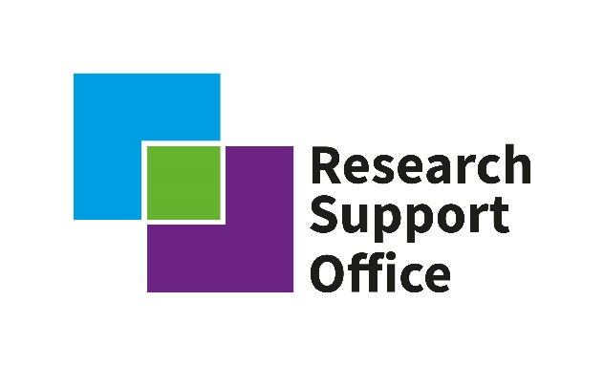
Radioactive Waste Management Research Support Office

Annual Conference

15-16 September 2021

Agenda

Day 1 – 15 September
09:00 Registration and coffee
09:50 Housekeeping – Helen Bayram (RSO Project Manager)
10:00 Welcome –Katherine Morris (RWM RSO Director) and Lucy Bailey (Head of the RSO)
10:05 Update on progress of the GDF programme and forward vision – John Corderoy (RWM)
10:25 Highlights from the RSO, decision making process and upcoming opportunities –Katherine Morris (RWM RSO Director) and Lucy Bailey (Head of the RSO)
10:45 Questions to RSO/RWM panel

11:00 Break

11:15 Discipline updates 1
- Materials – Claire Corkhill / Amy Shelton
- Social Sciences – Adrian Bull / Steve Brown
- Environmental – David Copplestone / Kat Raines
- Advanced Manufacturing - Steve Jones / Richard Hardy

12:15 Technical presentations 1 – Chair David Copplestone
- Effects on permeability of rock fracture geometry and fluid/rock temperature contrast - Gonҫalo Cunha (University of Edinburgh)
- The Microbial Impact on Cellulose Hydrolysis in a Cementitious Geological Disposal Facility - Naji Bassil (University of Manchester)
- Radionuclide biogeochemistry during sulfidation - Luke Townsend (University of Sheffield)

13:00 Lunch and poster session

14:30 Funding opportunities – Katherine Morris and Sam Shaw
PhD bursary call; overview of the application process and introduction of topics. RWM Subject Matter Experts on hand for any Q&A
LSSR workshop introduction

15:15 Introduction to ViSI system, with hands on demonstrations – Oliver Hall and Lucia Gray (RWM)

15:45 Coffee - During this break there will be a Bus Stop poster communication exercise for PhD students

16:45 Bus stop posters review and feedback
17:30 Dalton nuclear futures game activity with pre-dinner drinks

19:00 Conference dinner

Day 2 – 16 September
Coffee available from 8:30
09:00 Welcome - Katherine Morris (RWM RSO Director) and Lucy Bailey (Head of the RSO)
09:05 Plenary Talk, An Overview of the Paul Scherrer Institute Laboratory for Waste Management Activities in Support of the NAGRA Research and Development Program – Sergey Churakov (Paul Scherrer Institute)
10:00 RWM siting in the local community

10:30 Coffee

10:45 Technical presentations 2 – Chair Becky Lunn
- Potential functionality of a geological disposal facility digital twin- Kristof Bartha (University of Manchester)
- Corrosion and Leaching of Carbide Fuels - Dimitris Samaras (University of Bristol)
- Plutonium - Lewis Blackburn (University of Sheffield)
- Estimating the long term behaviour of vitrified nuclear waste: a natural analogue approach - Clare Thorpe (University of Sheffield)

11:45 Poster session: Overview of national research infrastructure including NNUF, DCF, and NERC facilities

12:30 Lunch

13:30 Discipline updates 2
- Radiochemistry – Francis Livens / Will Bower
- Geotechnical / Engineered barriers – Majid Sedighi / Matthew Kirby
- Applied Maths – Robert Zimmerman / Oliver Hall
- Geosciences – Kevin Taylor / Sally Thompson
- Gas – Kath Morris / Simon Norris / Andy Cooke
- Sub-surface Engineering - Becky Lunn / Dan Garbutt

15:00 Closing remarks
15:15 Coffee / close

