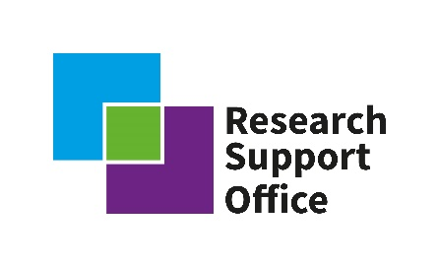
RSO Social Sciences PDRA Call: Application form
Project title
Investigator(s)
University / Organisation
Lead investigator contact details | Address
 | Tel. no
 | Email
RWM contact (if applicable)
Has the lead investigator received funding from RWM previously? |  |  | Y/N
If yes, provide details

List the main objectives of the proposed project (max 100 words)
Summary (max 200 words)
Describe the proposed project in simple terms in a way that could be publicised to a general audience
Confirm that the PDRA project would start by 1st June 2022 and complete in 18 months by 1st December 2023.
Yes / No – add comments if required.

Confirm that you will accept the RWM terms and conditions if awarded funding
Yes / No (please note, if stated “No” then the proposal will be excluded from the competition)

Provide clear details of the proposed research and provide a timeline for the proposal with key milestones. (Note, we are expecting the project to last around 18 months)

Please provide a clear proposal demonstrating alignment to the brief and define the necessary timescales, including a project work plan and/or Gannt chart. If experimental work will be undertaken, a clear strategy for delivering, analysing and synthesising appropriate data should be detailed.

Responses should include:
- A demonstrable understanding of the challenge area and complexities within that, referring to the research brief;
- A project plan / Gannt chart showing key phases of work, milestones and deliverables including completing within required period of time;
- Clearly defined input / time / resources that would be required from RWM, excluding industrial supervision, to support or enable the project, such as security clearance, or site visit to a licensed site;
- Identify any major risks to the research and mitigation that can be considered against these risks, including any risks of the research to be extended past agreed period of time;

(max 1000 words plus Gannt chart)

Please outline how the proposed research builds on existing knowledge and practice.

Clearly articulate where the proposal builds on existing understanding in the field, and how the proposal takes into account any changes that have taken place (technical, political, societal, etc) since any previous work in the topic was carried out and how the provided proposal is new research, not previously carried out in this context.

Please describe how the learning gained may be valuable to engendering community participation in public-sector decision-making process and in establishing community consent for major infrastructure projects.

Describe how the learning outcomes of the project could provide approaches, tools or guides that enable communities (particularly seldom heard demographics) to participate in community engagement, learning and decision-making process relevant to the development and consents for major infrastructure projects
Please show how the supervisory team has the required expertise in the relevant areas.

This section will be assessed in relation to career stage and experience. The inclusion of early career researchers, and / or researchers new to the nuclear industry, in the supervisory team is welcomed.

(max 200 words)

Please also attach a 1-2 page CV for the PI
Skills and capability generation

(max 200 words)

Identify the skills that will be developed by the proposed work and why they are relevant to the future of RWM.
Show how skills will be developed within the wider supervisory team.

Please provide a costed proposal, identifying additional ‘in-kind’ contributions which you can bring to the project. Note that the total budget requested from RWM must not be over £100,000.

Fund heading | Description (itemised to the nearest £1K) | Cost (£)
Researcher salary
Travel & Subsistence
Consumables
Directly allocated costs
Other
 | Total costs
 | Co-funding contributions
 | Other direct contributions
 | RWM grant requested
Please add details of co-funding, either anticipated or confirmed. If applicable, demonstrate ability to secure any further required funds or in-kind contributions to enhance the project. Include evidence of support where relevant.

