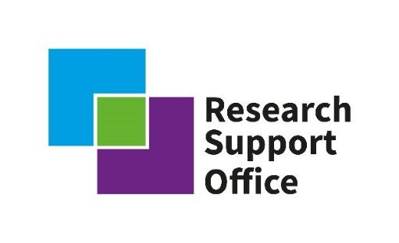

Advancing the safety case for a GDF in Lower Strength Sedimentary Rocks

Introduction
Lower Strength Sedimentary Rock (LSSR) formations are common across the UK, and possess and range of geochemical and geomechanical properties (e.g. porosity/permeability, mineralogy, brittleness/ductility, fracture characteristics, mineral-surface reactivity). Their common occurrence in the UK, combined with their favourable properties (e.g. low permeability), means that they offer potential opportunities for hosting a radioactive waste Geological Disposal Facility (GDF). In order to assess this potential further, fundamental underpinning research into the nature of an LSSR hosted GDF is required, including the detailed conceptualisation of the geology and groundwater of these systems. To underpin any safety case for a GDF in an LSSR, fundamental research is needed in key aspects of LSSRs.
The potential for locating a GDF within LSSR formations has recently been prioritised by RWM, with a programme of work currently running in this area. This activity, integrated with the research that will be funded in this programme, will be focused on developing an understanding of how the LSSR concept can be further modelled and conceptualised in the context of GDF disposability.
The initial plan is for a 4 year research programme funded by RWM and UKRI partners with an indicative budget of £2 to 4M.

Outline of Science Priorities for this call
This will involve research related to a number of discipline areas including geology, hydro/engineering geology, groundwater hydro-geochemistry, radiochemistry, mathematical modelling and others to provide underpinning information related to several overarching research questions:

- LSSR subsurface characterisation - Development of subsurface techniques and analysis protocols to characterise LSSR at multiple scales e.g. geology, fracture network, hydrogeology
- Conceptualisation of complexity and heterogeneity at multiple length scales in LSSR systems – Understanding key controls on subsurface properties e.g. fluid flow, radionuclide transport and geomechanical properties
- Geological and hydrogeological controls on flux of radionuclide and gases in LSSR – understanding radionuclide transport and fate, including the impact of the host rock mineralogy, groundwater geochemistry, micro/macro-structures and the excavation disturbed zone.
- Mathematical modelling – A cross-cutting theme focused on development of geosphere conceptual models and numerical solutions.
This programme will deliver impact in 3 keys areas, (1) defining LSSR research areas and objectives (2) development of the LSSR research community and skills, and (3) delivery of world leading underpinning research related to LSSR.
The questions highlighted above are representative research areas, we recognise that a key part of the initial stages (2021) of this programme will be to liaise with the academic community to develop these and other relevant research questions related to LSSR. The initial community consultation will be focussed on this activity, working alongside the RWM LSSR programme feeding in research understanding and an updated set of research questions relevant to GDF Programme by the end of 2021, which will inform a report from the RWM LSSR activities and any future research funding calls.

Process
We will convene an academic community workshop on November 8th 2021 to feed the academic community’s views into the RWM LSSR activities, from which the final scope and call(s) will be developed. The workshop will assist RWM and the RSO in understanding the current state of the research community. This includes the size, and the expertise and facilities available currently within the UK academic community. Finally, the workshop will also provide networking opportunities to the academic community to help facilitate potential collaborations for future calls. This will be followed by development of the formal announcement of opportunity in Spring 2022 and definition of the application, assessment and review process, with a view to projects commencing in autumn 2023.

