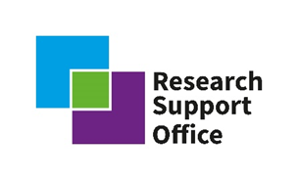

RSO Post-doctoral call: Guidance for submission and evaluation criteria

The Radioactive Waste Management Research Support Office (RWM RSO) is requesting applications for a post-doctoral research project in Applied Social Science.

The aim of the RWM RSO is to develop a portfolio of research projects focused on key RWM research priorities. The specific aims of the programme are to:

- Develop key skills required for RWM’s research mission over the coming decades, and to help deliver the next generation of geological disposal scientists, engineers and other researchers;
- Expand all aspects of the geological disposal research community throughout the UK;
- Encourage collaboration and communication between RWM and the academic community.

The research project in the Applied Social Science will run for 18 months, as such we are looking for projects that will start in early 2022. The project proposal is expected to have total cost of less than £100,000. Universities and research groups that have not previously received funding from RWM are particularly encouraged to apply. The contractual arrangements for the project will be administered by RWM. We are seeking proposals from academics able to support a PDRA with this research, as opposed to applications directly from PDRAs. Applicants may have a researcher in mind whilst applying and will be responsible for recruiting a suitable candidate when the contract is awarded.

Call structure

Request for proposal sent on: | 28th September 2021
Clarifications period closes on: | 9th November 2021
Request for proposal closes on: | 30th November 2021

All clarification questions (including commercial, technical and terms and conditions) should be sent before the clarification period is closed and addressed to the RSO via rso-gdf@manchester.ac.uk.

Any clarification questions or proposed changes to the scope of the project and/or grant agreement terms will only be considered during the Clarification period stated above and will not be accepted after proposal submission.

Proposals will be accepted as Word documents and supporting materials emailed to the RSO inbox: rso-gdf@manchester.ac.uk. No proposals should be coming to RWM staff directly. Applications will be assessed by a panel led by RWM.

Applied Social Science – Citizen Participation

Applicants are sought for a research project on citizen participation in the development of major infrastructure projects and the associated community level decision making. The PI for this research can be based at any UK university. The project will be funded for an 18- month period by Radioactive Waste Management (RWM) and administered through the ‘applied social science’ stream of RWM’s Research Support Office (RSO).
It is the policy of the UK Government to manage higher activity radioactive waste in the long-term through geological disposal. The policy framework to find a suitable site and willing host community for a Geological Disposal Facility (GDF) was established by the UK and Welsh Governments through their Working With Communities policies in 2018 and 2019.
RWM is the delivery body for a GDF and will work in partnership with communities to identify a suitable location to host a facility. Finding a suitable location for a GDF is a process that will take many years. It is a requirement of the Working With Communities policies that a GDF be hosted by a willing community. That community willingness will be established though extensive partnership working with communities and a Test of Public Support. The siting process itself is based on community consent and must be open, transparent, as flexible as possible and democratically accountable. RWM has published Community Guidance to support our engagement with communities and the formation of Community Partnerships. The timeline for the siting process is depicted below:
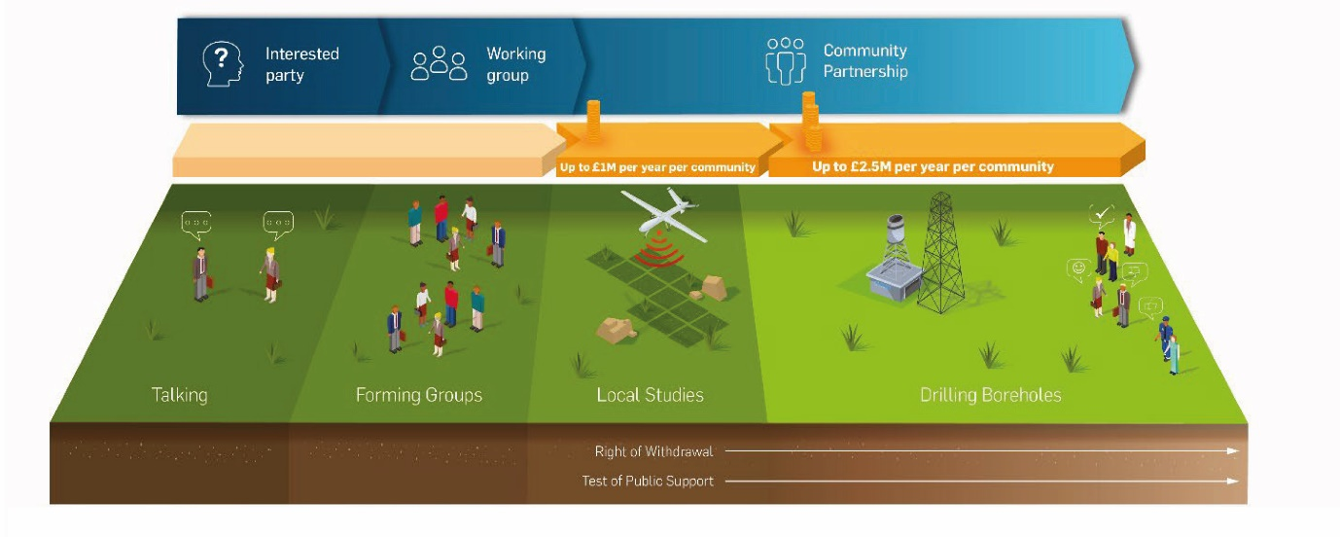

RWM currently has two Working Groups and is looking to form additional groups in this calendar year, 2021.
Citizen participation in any community consent-based process is key to its success and legitimacy by ensuring citizens have a direct voice in decision making. The theory of citizen participation has been described previously, and has been recently described by practitioners in the UK.
RWM is seeking to understand the latest insights and the most effective approaches to involving and engaging citizens in the development of major projects and the associated decision making which can further inform our approach to partnership working with communities. This will be useful in shaping RWM’s ongoing engagement with communities – both those which are already involved in the siting process, and those who may be contemplating future involvement. It will also inform RWM’s engagement with broader society.
RWM is interested in proposals for research which build on established thinking and practice in citizen participation and can be translated into the current social and political context of England and Wales where communities have raised expectations of developers and public bodies, particularly driven by digital technology, the availability of information and the reshaping of society post Brexit and COVID19. Research topics may include studies into making engagement more inclusive, more participant-focused, more effective, better informed, more representative, more transparent, or quicker – or any combination of these, or other attributes.
Successful proposals will demonstrate an established academic record of research and publication in the social sciences and/or citizen participation, ideally with experience of research on science and technology, or industrial science. The research proposal should outline:
- how existing research and state of the art will be established
- how the work could help RWM respond to recent and future systemic changes in society e.g. Brexit, COVID19, the UK Government’s ‘levelling up’ agenda
- scope of any fieldwork the researcher would like to undertake
- how the work might inform the definition of any longer-term research RWM may decide to commission on the topic
The research timetable and proposed outputs should include a synthesis of the findings in respect of their generic applicability to major infrastructure projects, and also more specific discussion of how these findings might inform RWM’s approach to community engagement in the siting process for a GDF.
Funding for the research will be oriented to the appointment of a post-doctoral researcher for the 18-month period.

Proposals evaluation criteria

The details requested from applicants and how these will be evaluated are as follows:

- Confirm that the project would start on the 31st January 2022 and be completed by 31st July 2023.

Applicants are requested to confirm the project will be able to start in 2022 and be completed within 18 months.

PASS/FAIL

- Acceptance of the attached terms and conditions of the grant is mandatory:
- Acceptance of the attached RWM terms and conditions is mandatory. A completed grant agreement isn’t needed with the application, but will be required if funding is awarded.
- If the grant agreement is not signed on award, then funding will not be issued.
- If after the grant award the grant agreement is not signed within 30 days, then RWM reserves the right to withdraw the award of the grant.

PASS/FAIL

Please state “Yes” or “No” on the application form. Other answers will be deemed non-compliant.

- Evaluation criteria:
Scoring criteria | Score | Weighting (out of 100%) | Description of requirements and guidance notes
Please provide a clear proposal taking into account the necessary timescales, including a project work plan and/or Gannt chart. If experimental work will be undertaken, a clear strategy for delivering, analysing and synthesising appropriate data should be detailed. | /4 | 25% | An ideal response will provide a clear and credible research design taking into account the necessary timescales. If experimental work is required, a clear strategy for delivering and analysing appropriate data will be included. Responses should include:  - A project plan / Gannt chart showing key phases of work, milestones and deliverables including completing within required period of time;  - Clearly defined input / time / resources that would be required from RWM, excluding industrial supervision, to support or enable the project, such as security clearance, sample access or site visit to a licensed site;  - Identify any major risks to the research and mitigation that can be considered against these risks, including any risks of the research to be extended past agreed period of time;  - Identify any use of external facilities, such as NNUF or other national / international infrastructure and demonstrate that proposed activity has been discussed in advance with the relevant facility owners and is feasible within the bounds of the proposal.
Please provide a proposal which evidences how the work will build existing knowledge and practice. | /4 | 15% | An ideal response will clearly articulate where the proposal builds on existing understanding in the field, how the proposal takes into account any changes which have taken place (technical, political, societal, etc) since any previous work in the topic was carried out and how the proposal is new research, not previously carried out in this context.
Please provide a proposal which makes clear how the learning gained may be valuable to engendering community participation in public-sector decision-making process and in establishing community consent for major infrastructure projects. | /4 | 15% | An ideal response will describe how the learning outcomes of the project could provide approaches, tools or guides that enable communities (particularly seldom heard demographics) to participate in community engagement, learning and decision-making process relevant to the development and consents for major infrastructure projects
Please provide CV’s for the Principal Investigator (s) and any researcher proposed to undertake the work (if identified at this stage) | /4 | 15% | An ideal response will provide a clear track record of relevant research. This section will be assessed in relation to career stage and experience.  The inclusion of early career researchers, and / or researchers new to the nuclear industry, in the supervisory team is encouraged.
Please provide a costed proposal, identifying additional ‘in-kind’ contributions which you can bring to the project. | /4 | 30% | Identify cost breakdown between Staff costs and Research & Training Grant. If applicable demonstrate ability to secure any further funds or in-kind contributions.
Scoring criteria:
0= No response or response does not meet any requirements
1= Marginal response with significant drawbacks or omissions
2= Acceptable response, meeting most criteria with only minor drawbacks or omissions
3= Good response which meets all requirements
4= Excellent response which meets and exceeds requirements

https://assets.publishing.service.gov.uk/government/uploads/system/uploads/attachment_data/file/766643/Implementing_Geological_Disposal_-_Working_with_Communities.pdf
https://gov.wales/sites/default/files/publications/2019-04/geological-disposal-of-higher-activity-radioactive-waste-guidance-for-communities.pdf
https://www.gov.uk/guidance/communities-and-gdf
https://lithgow-schmidt.dk/sherry-arnstein/ladder-of-citizen-participation.html
https://pages.uoregon.edu/rgp/PPPM613/class10theory.htm
https://www.involve.org.uk/resources/publications/project-reports/pathways-through-participation

