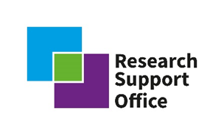

Community of Practice (COP) in Advanced Manufacturing and Geological Disposal of Higher Activity Radioactive Waste

Dr Steve Jones University of Sheffield: Advanced Manufacturing Theme – Discipline Lead

Richard Hardy NDA: Advanced Manufacturing Theme – Nuclear Waste Services Subject Matter Expert

Introduction and background

Nuclear Waste Services (NWS), part of the NDA group, is undertaking the biggest clean-up project in Europe as they work to provide permanent answers to the UK’s radioactive waste. Academic research will provide insights that underpin the implementation of a UK Geological Disposal Facility (GDF). The Nuclear Waste Services Research Support Office (RSO) was launched in 2020 and is working to develop academic collaborations and build long-term research partnerships focused on all aspects of geological disposal. This national partnership programme fosters a multi-disciplinary approach to radioactive waste management, and our academic insights will underpin the GDF programme and support the development of the next generation of researchers in this area.

To support these endeavours, we are seeking to create a Community of Practice (COP) with academic and industrial stakeholders focused on our advanced manufacturing research discipline. This COP will advise on and develop appropriate research projects with Nuclear Waste Services, and with other funders, which will provide a safer future to manage radioactive waste effectively through underpinning the delivery of a Geological Disposal Facility. This major project requires world-class engineering, science and technology involving:
- isolating the radioactive waste in sealed vaults and tunnels deep underground, between 200 m and 1000 m below the surface
- allowing the waste to undergo radioactive decay for extended time to reduce its radiotoxicity
- preventing radionuclides from ever reaching the surface in levels that could cause harm

In addition to this a GDF is likely to require design to include:
- No ongoing maintenance beyond the multi-decade operational period
- Remote emplacement
- To be robust against human intrusion providing improved security over surface storage
- To be less vulnerable than surface storage to natural processes such as glaciation or climate change

The advanced manufacturing research areas that are of immediate interest to the Nuclear Waste Services RSO include the key themes of: architecture and intelligent infrastructures autonomous and remote technologies; asset management and security, and waste container performance.
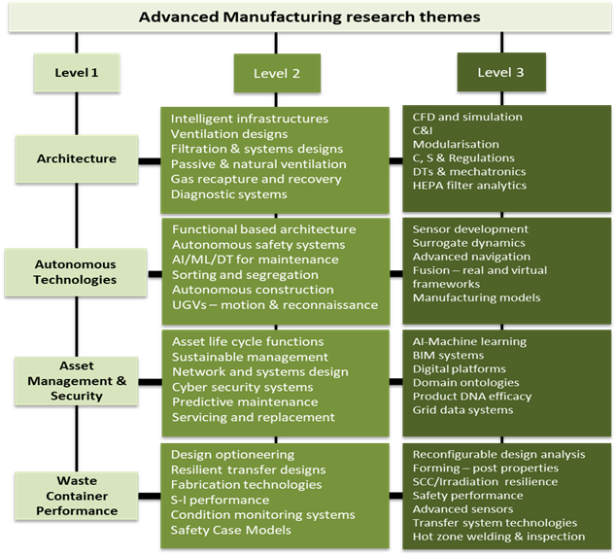
Figure 1 – Advanced manufacturing research themes

Subsets of these disciplines, as illustrated in figure 1, will require members of our COP to be proficient exponents in those relevant engineering principles and practices associated with automation and digitalisation, artificial intelligence and analytics, additive and near net shaped fabrication, codes, standards and regulations, mechatronics and controls and instrumentation, modularisation, structural integrity, inspection and assurance.

SMART objectives for our 2022/2023 advanced manufacturing research theme are:
- Provide a manufacturing framework supporting future optioneering of high-heat generating waste (HHGW) disposal containers.
- Support design and safety feasibility applied to high-integrity waste management systems utilising artificial intelligence.
- Consider the benefits of adopting autonomous manufacturing systems.
- Establish a network of manufacturing experts from across academia, RTOs and Industry to proactively inform and guide future research projects, using multifarious sectorial input to underpin the GDF programme in Advanced Manufacturing areas and across disciplines.

Why should I do this, what’s in it for me or my organisation?

Whilst this is a volunteering (in-kind) activity the following benefits are noted for you to consider:

- Build your network, knowledge and positively influence change in the UK’s nuclear decommissioning and waste management programme as part of one of the UK’s biggest infrastructural projects to ensure the safety and integrity of radioactive waste over the next 150 plus years
- Help shape research area prioritisation and deliver significant programmes of research to support the GDF development
- Inform and potentially bid for research projects that could support researchers hosted within your organisation and provide a future talent pipeline of skills.
- CPD activities that translates your specialist engineering skills to the next generation of students and engineers to tackle a national infrastructure need.
- Awareness of the latest Nuclear Waste Services activities and developments, undertake consultation peer reviews and potentially co-publish work

The level of personal activity from each community member is expected to involve one full day of effort per year, which will consist of two hour meetings each quarter. Each meeting session will have a specific theme, allowing individuals to effectively plan their diaries in advance to minimise any disturbances to their normal working practices.

Group membership and application process

We are expecting the CoP membership to include people from academia, Research and Technology Organisations (RTOs), industry stakeholders or supply chain, and regulators. The CoP will revolve around key themes of: architecture and intelligent infrastructures, autonomous technologies, asset management and security, and waste container performance. As such, we are hoping to gather together individuals with experience in one or more of these themes, and expertise in one or more relevant areas such as manufacturing, robotics and automation, digital processing, civil engineering, structural integrity, and materials.

Initially we are looking to gather a group of around 14 people, with a mixture of backgrounds and expertise across the key themes. There is a short application form to complete (below). Please submit this, along with a brief (no more than 2 page) CV to rso-gdf@manchester.ac.uk by 9th September 2022.

Applications will be evaluated based on knowledge of and profile in relevant research discipline, as evidenced within the application form and short CV. During review, consideration will also be given to ensure a balance of knowledge and backgrounds across the research themes.

Application form

Name
Email
Institution / organisation
Position
Which theme(s) do you have expertise and experience in? | - Architecture and intelligent infrastructures  - Autonomous technologies  - Asset management and security  - Waste container performance

Why would you like to join the Advanced Manufacturing CoP?
(200 words)

Summarise your professional knowledge, experience and network in one or more of the research themes
(200 words)

