Open Call for Academic Leadership Role in Radiochemistry, supporting the UK geological waste disposal programme
Post Reference: NuclearRSO/DL008/RCHEM
No of roles: 1
Duration: Up to 6 days pa
Remuneration: Honorarium
Closing Date: 14 October 2024
Post Category: Discipline Lead (academic)
Business Unit: Nuclear Waste Services RSO
Location: Manchester / UK-wide
Background. The Nuclear Waste Services Research Support Office (RSO), led by Katherine Morris (Manchester), Claire Corkhill (Bristol), Sam Shaw (Manchester), and Lucy Bailey (Nuclear Waste Services), acts as a hub, with the mission to work with leading universities to co-ordinate research aligned to Nuclear Waste Services’ needs.
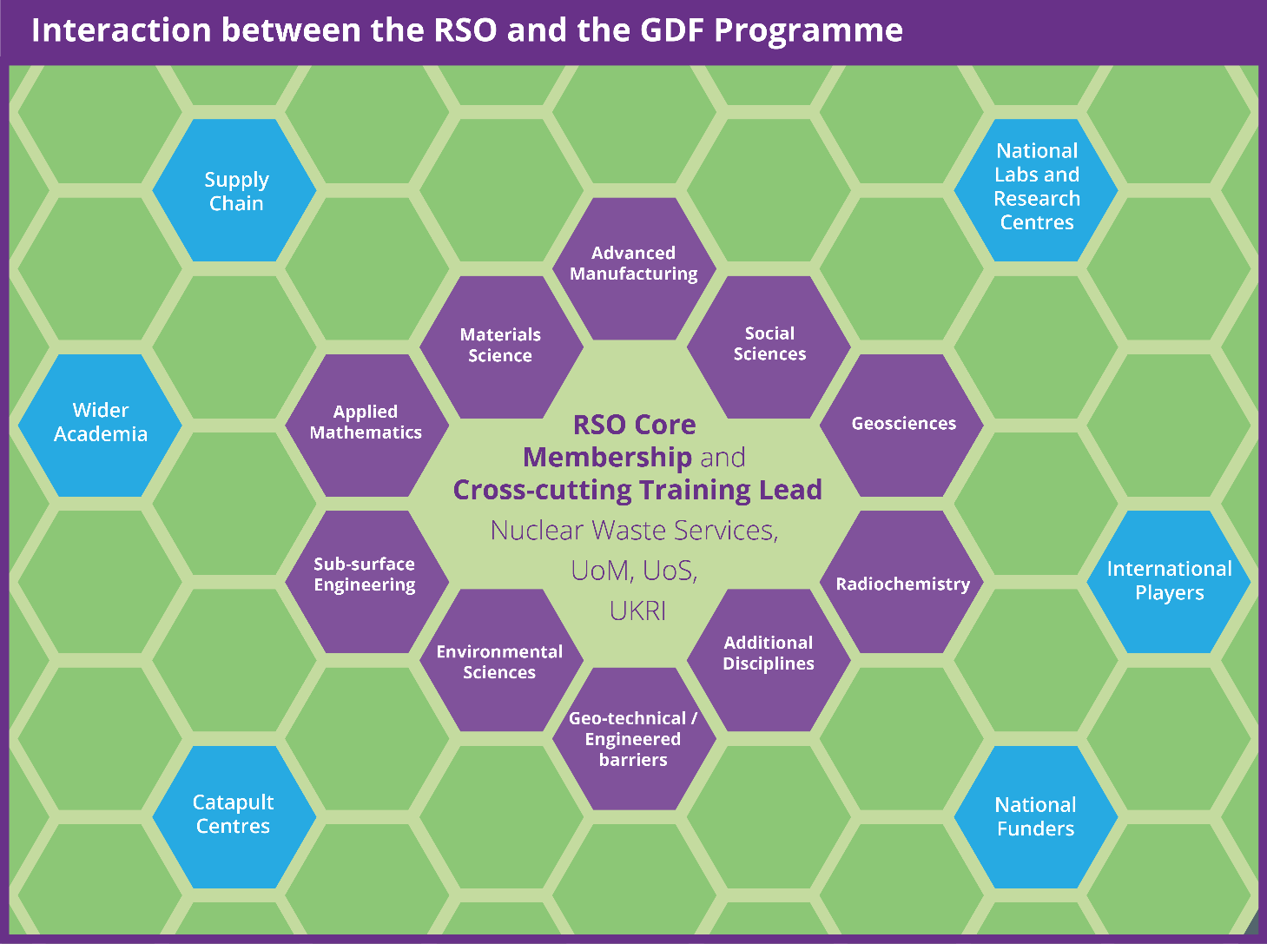
Figure 1: Interactions between the RSO and the GDF Programme

The RSO was launched in 2020 and has established a collaborative working dynamic between academic Discipline Leads, Nuclear Waste Services Subject Matter Experts (SMEs) and the RSO Core Team leading to multiple calls for research funding. The Discipline Leads have proved invaluable for both their expertise and reach into the wider academic community in their respective fields. Since the establishment of the RSO, Radiochemistry research has contributed to the underpinning research of the geological disposal facility (GDF) safety case. Due to a change in personnel we are seeking to identify a new Discipline Lead in the Radiochemistry area. This new Discipline Lead will work closely with the other Discipline Leads already in place (see Table 1) and their Nuclear Waste Services counterparts.
The Role. The Discipline Lead in Radiochemistry will work within the RSO to deliver relevant research needs (both within discipline and multi-disciplinary). They will therefore have to engage with the wider academic, research and innovation communities (e.g. other universities, UKRI, Catapult Centres, National Nuclear Laboratory, BGS, STFC facilities and EU / international funders). Discipline Leads will work with Nuclear Waste Services to develop a set of SMART objectives for their discipline. They will each work closely with a relevant Nuclear Waste Services subject matter expert and the RSO Core Team to assist the community in developing high quality, relevant research projects. Since the research programme will often overlap multiple disciplines, it is very important that the Discipline Leads function well as a team, and work effectively together (as illustrated in Figure 1 above).
The Person. The Discipline Lead will be an academic researcher with a responsibility to understand Nuclear Waste Services’ mission and research needs in the context of their discipline. They also need to understand their community and represent it within the RSO. The Discipline Lead will support and develop their community and demonstrate leadership in this role. They will lead topic meetings, attend and present outcomes at the Programme Executive and, with support of the Core Team and their community, foster new proposals for the Nuclear Waste Services-run funding competitions. Appointees may be drawn from academia or industry and all levels of academic career will be considered.
Arrangements. It is expected that the Discipline Lead role will require a commitment of around 6 days pa, and for this an honorarium will be offered. The costs of travel and subsistence incurred in connection with the role will also be covered. These roles will be administered via a letter of terms from The University of Manchester. The appointment will be for an initial term of 1 year and subject to an annual review.
Assessment. To apply for the Discipline Lead role, please complete the application form at the end of this document and send it, along with a summary CV (2 pages max), to rso-gdf@manchester.ac.uk
To discuss this opportunity further, please send any queries to the RSO (rso-gdf@manchester.ac.uk).
Closing date: 14 October 2023
As an equal opportunities employer we encourage applications from all sections of the community regardless of gender, ethnicity, disability, sexual orientation and transgender status. All engagements are made on merit.

Discipline | Lead | Discipline Scope
Geoscience | Kevin Taylor | Geoscientific understanding is essential for building confidence in the long-term safety of a geological disposal facility (GDF) and for quantifying and managing the inevitable uncertainties that arise over the timescales associated with geological disposal. Geoscience research involves integrated aspects of rock characterisation; hydrogeology, geochemical reactivity and modelling; geophysics; geomechanics and structural geology
Radiochemistry | Vacant | Understanding the mobility of radionuclides under different conditions is an essential component of the GDF safety case. Radiochemistry research addresses the impact of chemical speciation on solubility and mobility of radionuclides and stable species, particularly on exchange between solid and fluid (solution and gas) phases through both experimental study and computational modelling.
Materials Science | NA | Materials science research underpins the safety case for radioactive waste disposal. It provides the basis for understanding the long-term behaviour of wastes and engineered barrier components within a GDF, to define a GDF source term. Research includes the evolution and interaction of the engineered near field components of a GDF, during the operational phase and following the sealing and closure of the facility. It covers the wasteform, container and buffer or backfill, addressing individual and coupled thermal, hydrological, mechanical and chemical processes.
Advanced Manufacturing | Steve Jones | Advanced manufacturing research is intrinsic to building sustainable waste management systems and to securing the necessary societal and environmental investments. Research involves the development of cost-effective fabrication and construction technologies, and standardisation and automation that enhances product integrity and performance.
Environmental Science | David Copplestone | Delivery of a GDF will require appropriate environmental permits, environmental impact assessments, habitats assessments and sustainability appraisals. Environmental science research addresses the impact of a GDF on, and incorporation of disposed waste components in, the biogeochemical cycles which operate in the sub-surface and surface environments, across all relevant length and time scales to support these assessments. Research is required to understand biogeochemical cycling in sub-surface and surface systems and all issues of biosphere evolution (including climate change) relevant to deep geological disposal.
Applied Mathematics | Robert Zimmerman | Regulatory guidance requires a quantitative evaluation of the performance of a GDF during each of the transport, operational and post-closure phases. The applied mathematics theme will explore the development and application of quantitative descriptions for the key features, events and processes which may impact the safety and operation of the GDF throughout its lifecycle. It will complement existing Nuclear Waste Services expertise in mathematical modelling and the quantification and management of uncertainties.
Applied Social Science | Adrian Bull | The provision of a geological disposal facility (GDF) relies on the consent of the host community. The applied social science theme will explore all social and socio-economic aspects of delivering the GDF. It will also explore how public trust and confidence can be developed and sustained, to secure the necessary community consent.
Training | Scott Heath | A GDF programme will require a secure supply of technical training across a wide range of disciplines. The Training Lead will coordinate training activities across the RSO portfolio, and integrate them into wider nuclear skills development activities.
Sub-surface Engineering | Becky Lunn | The GDF will be a significant underground construction project involving state-of-the-art research on rock mechanics, geophysics for rock mass characterisation, borehole construction/monitoring, mining and underground construction. Research will also require exploration in sustainability and maximising all aspects of underground space inclusive of infrastructure for transportation, utility systems, storage architecture and trenchless technologies. Research on state-of-the-art site investigation techniques and novel, adaptive underground construction methods, will be key to its success.
Geotechnical / Engineered Barriers | Majid Sedighi | Geological barriers, engineered barriers, wasteforms and the interfaces between them are key components to any GDF safety case. The drilling of boreholes, shafts, tunnels and vaults all create voids, surrounded by Excavation Disturbed Zones, which must be sealed with barrier materials (e.g. cement and bentonite). Research to understand, and engineer, the spatial and temporal evolution of hydro-chemo-mechanical properties of each barrier material, as well as the transition zones and interfaces in-between, is crucial for understanding groundwater flow, saturation and long-term gas migration; a critical success factor in achieving the GDF’s safety case.

Table 1: RSO Discipline Leads and Scope

Nuclear Waste Services RSO Discipline Lead Application Form
To apply for a Discipline Lead role, please complete the application form below and send it, along with a summary CV (2 pages max), to rso-gdf@manchester.ac.uk
Name:
Organisation:
Position:
Contact email:

Summarise your professional knowledge, experience and network in the relevant discipline (200 words):

Summarise your expertise in research leadership and management, relevant to the role (200 words):

Describe how you would approach networking within the wider community and facilitating research, as part of the RSO team (200 words):

Describe your track record of public and professional engagement, including that related to the GDF programme (200 words):

What do you think are the key challenges for the GDF programme and how would you address these in your contribution to the role within the RSO going forward? (200 words).
Requirements for the Nuclear Waste Services RSO Discipline Leads and how we will assess your application:
Requirement | Assessment question | Evidence
Knowledge of and profile in the relevant research discipline | Summarise your professional knowledge, experience and network in the relevant discipline. | Response / cover letter  CV
Expertise relevant to delivery of the role | Summarise your expertise in research leadership and management, relevant to the role. | Response / cover letter  CV
Approach to working in a team capacity | How you would approach networking the wider community and facilitating research, as part of the RSO team? | Response / cover letter
Track record of relevant public and professional engagement | Describe your track record of public and professional engagement, including that related to the GDF programme. | Response / cover letter  CV
Strategic insight into the delivery of the GDF project | What are the key challenges for the GDF programme relevant to your discipline, and the role of the RSO going forward? | Response / cover letter

